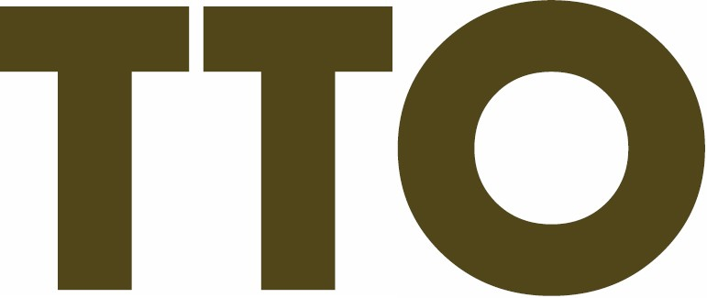 ®?
•
TELLINGTON TTOUCH is a system of gentle bodywork and movement exercises which
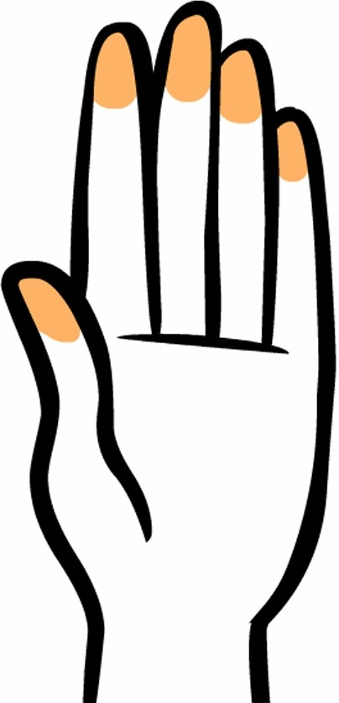
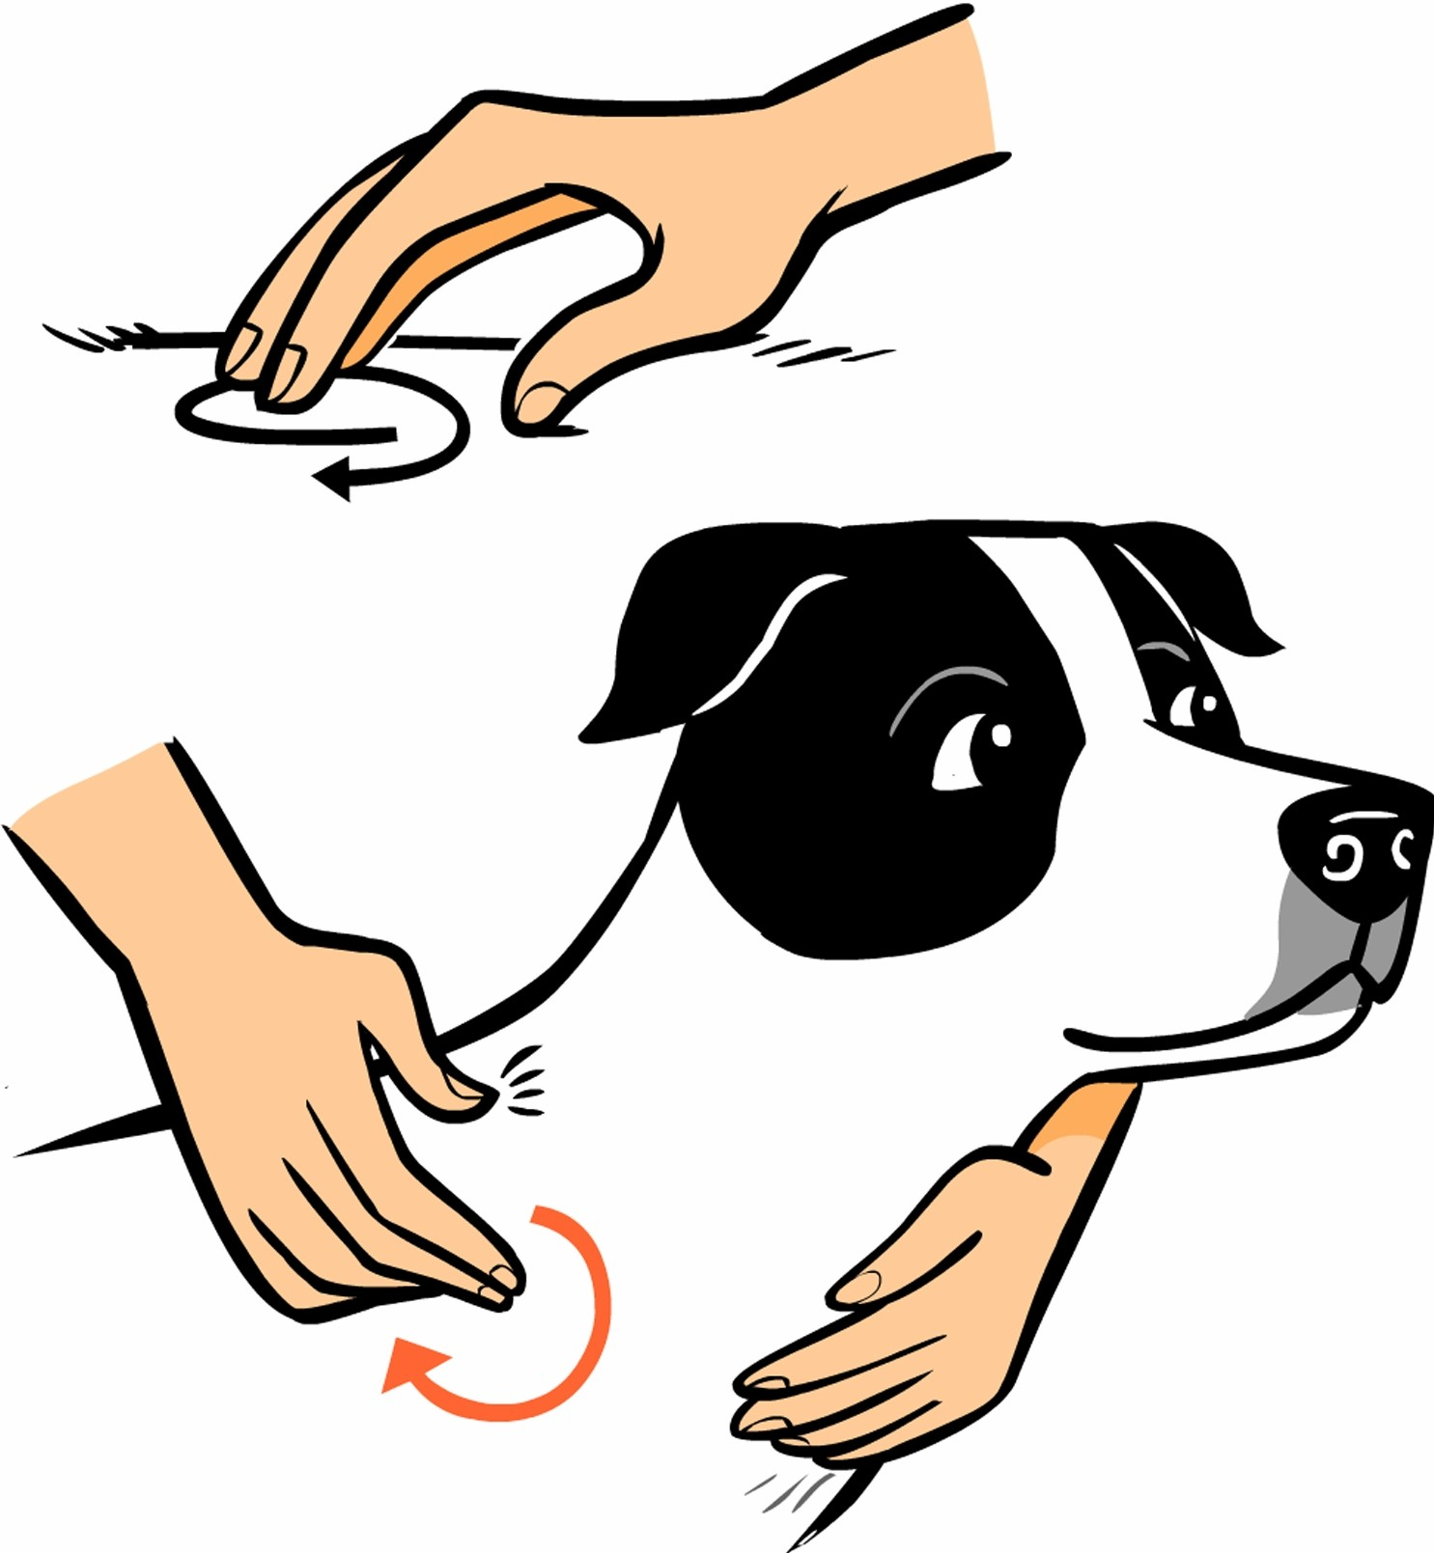
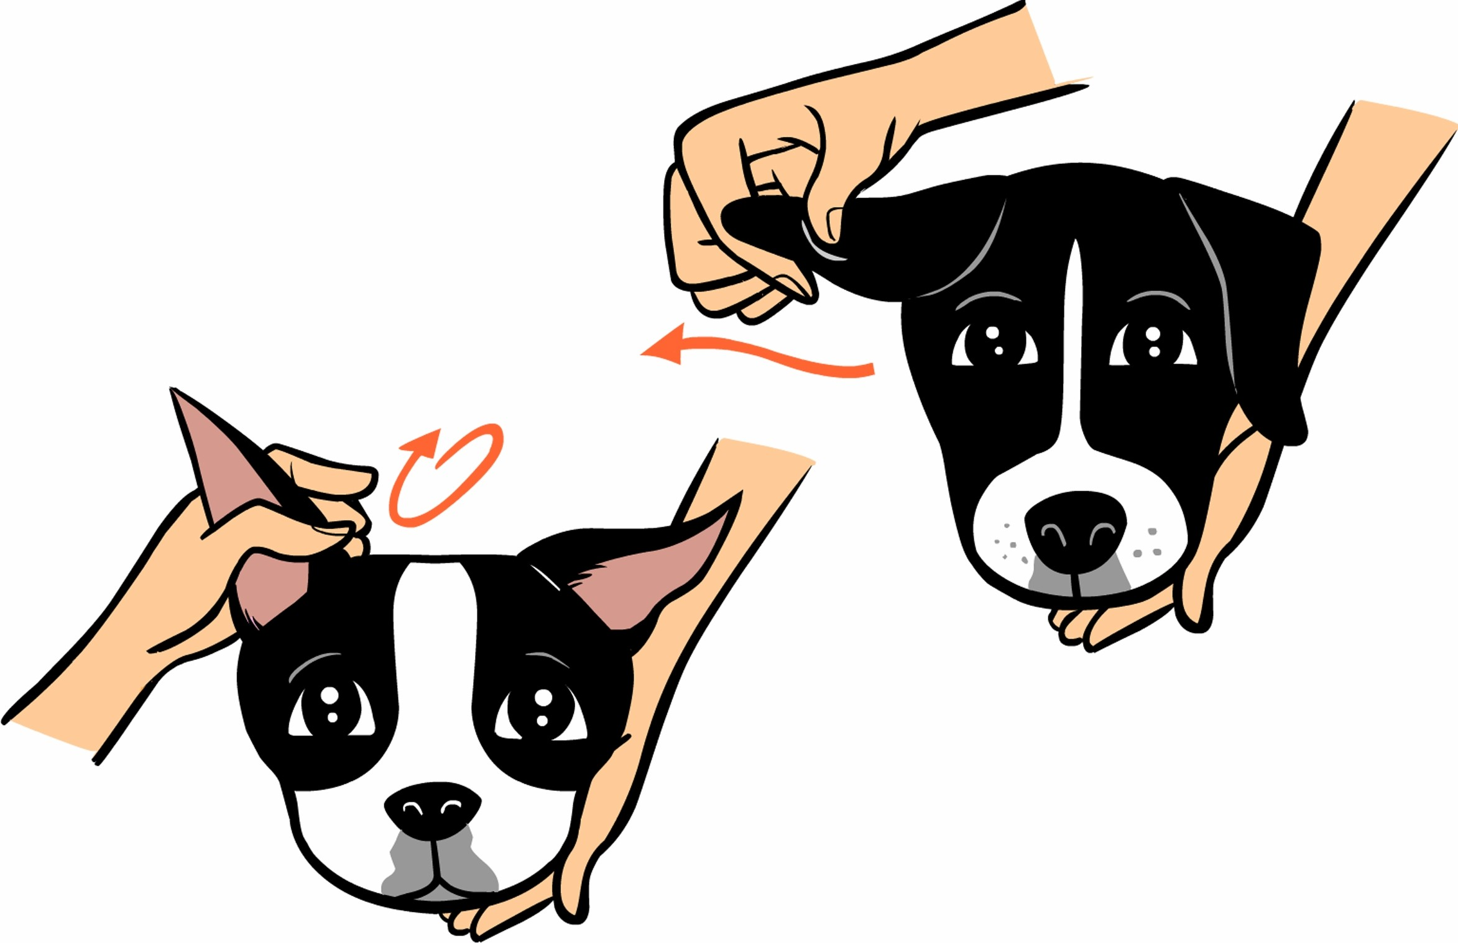
positively influence behavior and wellbeing in dogs. Tlouch is based on co-operation and understanding and will deepen the relationship between dogs and their people.

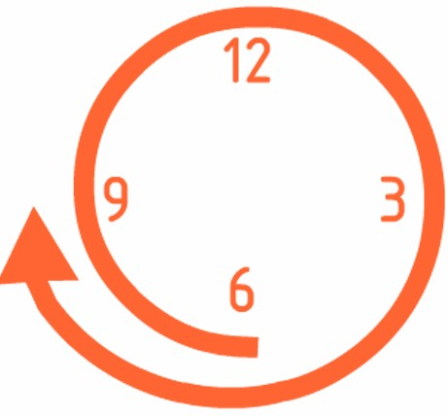
THE CLOUDED LEOPARD TTOUCH
is the foundation for all circular TTouches. The name describes how the hand is placed on the body - as lightly as a cloud. This TTouch brings awareness and improves the dog's ability to learn. It has also proven to be especially effective for nervous and anxious dogs and can also help dogs feel more confident in
new and challenging situations.
THE EAR TTOUCH is one of the most important things you can do for your dog! There are many acupuncture points in the ear, which when stimulated will provide beneficial results. The Ear TTouch is particularly important in cases of emergency and shock. This TTouch helps induce relaxation, reduce stress,
improve digestion and overcome fatigue and car sickness.

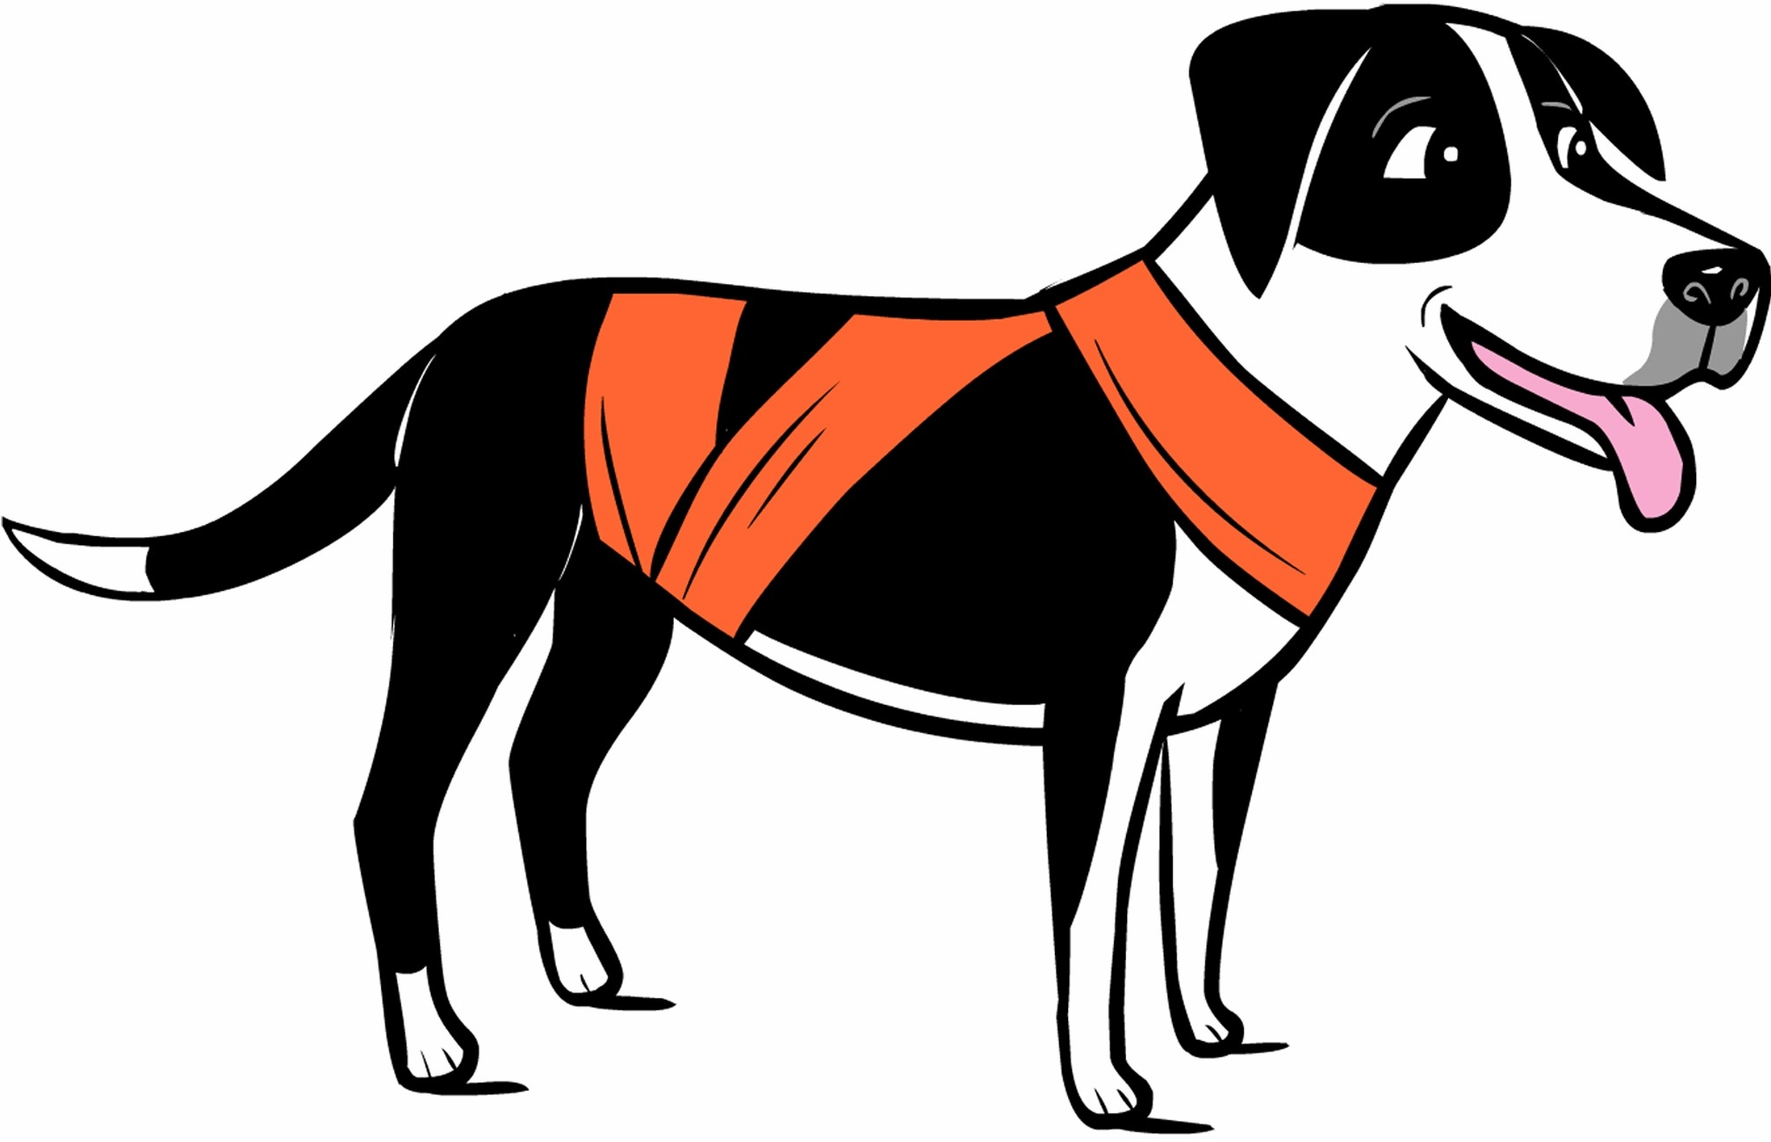
THE BODYWRAP enhances a dog's sense of his own body and makes him more confident in his movements and behaviour. It is especially beneficial for dogs that are afraid of loud noises,
are nervous, hyperactive or experience panic when travelling in a car. The bodywrap gives the dogs a sense of connection and feedback about tension and space.

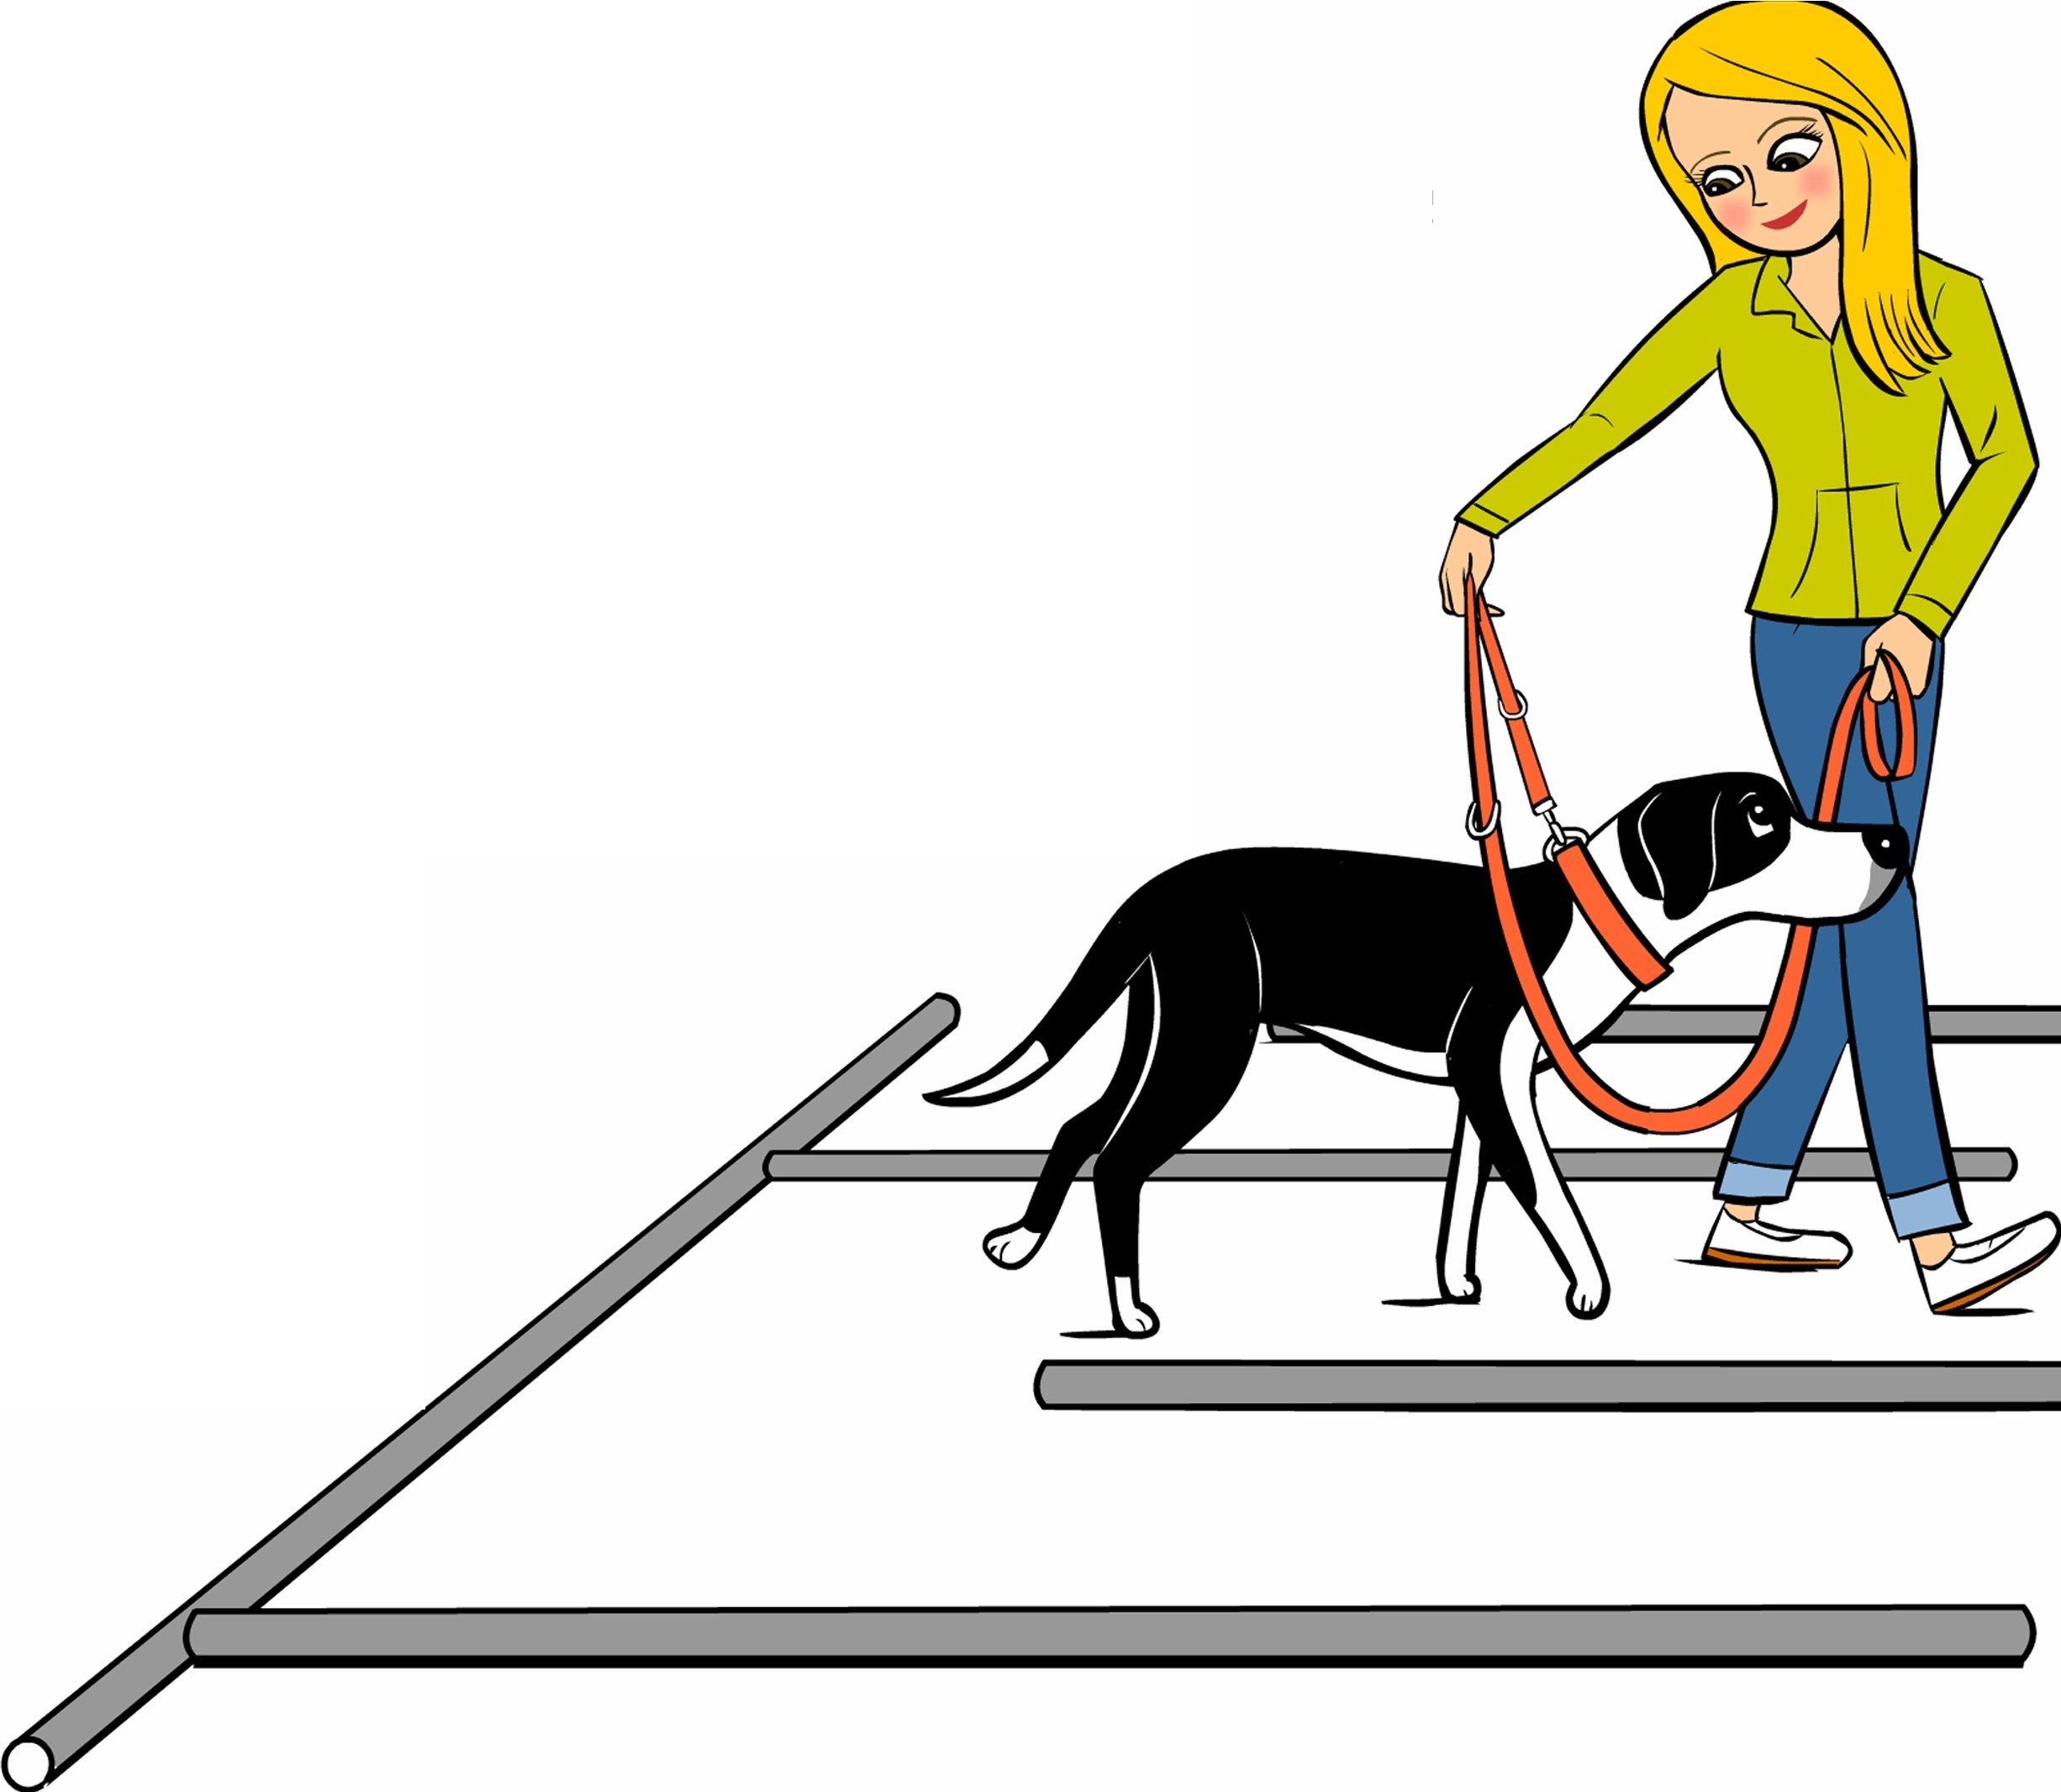THE BALANCE LEAD is a simple technique to help dogs come into balance should they pull on the lead. It takes the pressure off the neck and onto the chest and brings the dog's weight back over his feet instead of leaning forward.

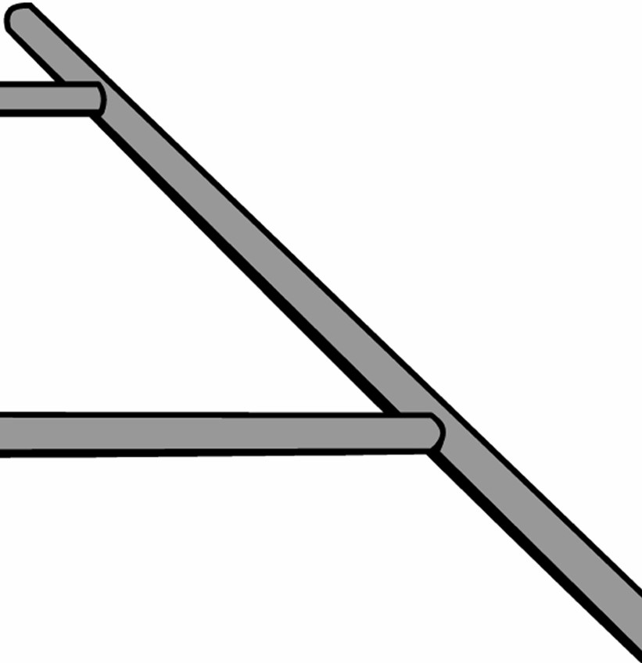
THE LABYRINTH requires the dog to negotiate
a simple course made of poles laid out on the ground. This exercise helps to improve coordination, concentration, focus, balance and self-control.

All in all, TTOUCH is something we do FOR dogs, not to them!
CV?
••
V

Ma"e Your Dog mi\e
©Copyright 2012 Jetta Reis www.makeyourdogsmile.net
Artwork by Lili Chin www.doggiedrawings.net

